**Results**

* Result of Objective 2
  + European level
  + Detour index vs. cumulative population graphs
  + Clustered
  + By region
  + Local significance?
  + Tree / graphs like in Wolff, Scheuer et al. 2020
  + Maps like in Kabisch et al. 2016

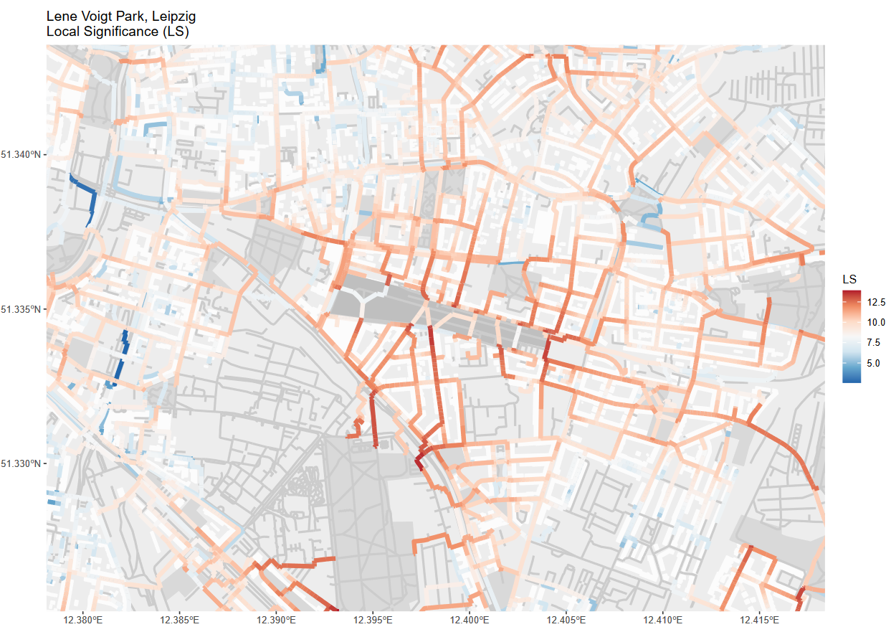

*Figure 2: The network colors depict the cumulative Local Significance index (LS). A higher LS value is depicted by a darker red color, representing i.) more people taking this path, ii.) the people taking this path are living in closer proximity to the green space, and / or iii.) the path is leading to a larger green space. Since the LS values are cumulative, a higher value might also mean more paths from different buildings overlapping (See Appendix … for further information).*

* City scenarios
  + Base indicators
    - Figure X displays the local significance (LS) values that we calculated for the city of Leipzig, Germany.
  + (Map description (leave here or Appendix?))
    - The map shows the area east of the city center (top right corner of the map).
    - In the center of the map, highlighted with a darker gray, is located the Leve-Voigt-Park (LVP).
    - Other green spaces are depicted in a lighter gray, buildings and the network in white and gray, respectively.
    - Since the LS values tend to grow exponentially, we decided to display the logarithm of the index.
    - Lower LS values are displayed in blue shades, higher values in red shades.
    - Due to the high density of green spaces and residential buildings in the area, an overall high level of LS values can be observed.
    - Especially high LS values occur in close proximity to the LVP.
    - The highest values can be found at park entries adjacent to streets which connect the LVP to areas with high population.
    - The eastern part of the LVP close to the *Riebeckestraße* is a good example for this.
    - Here, we find high LS values at those parts of the streets that lead to the residential areas in the north, east and south-east.
    - Likewise, the *Josephinenstraße* which connects the center of the LVP to the next larger park in the south, the *Friedenspark*, displays high LS values.

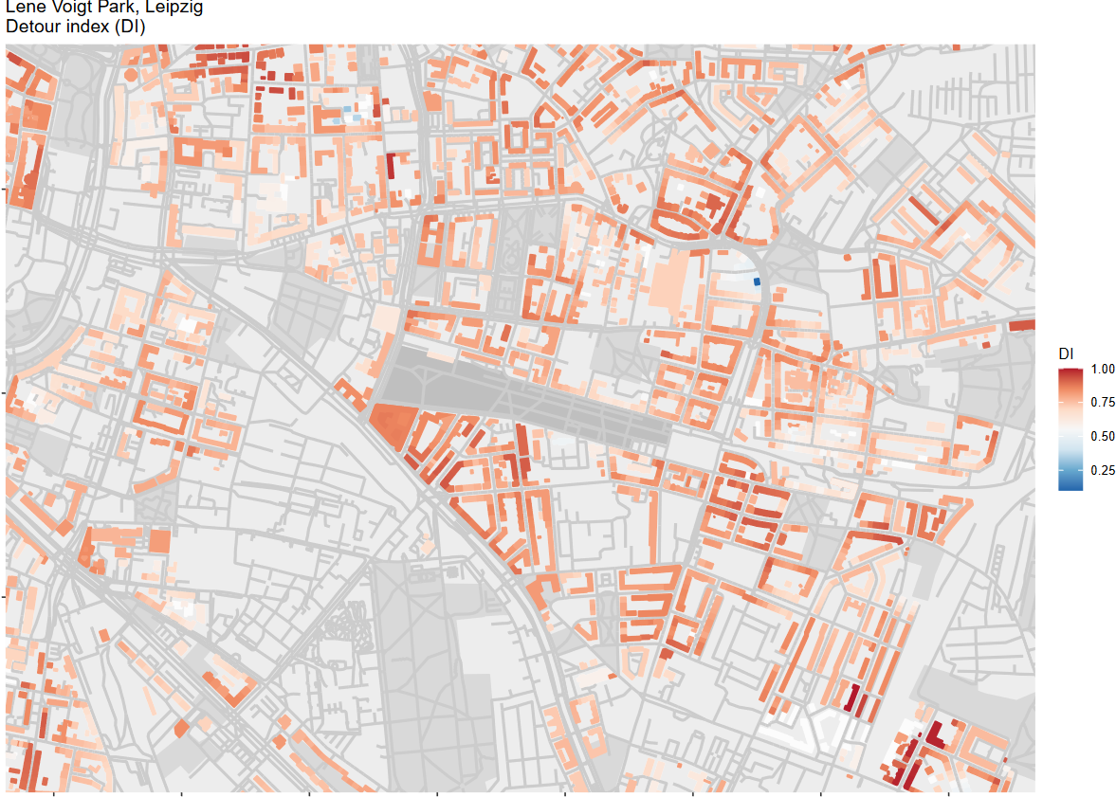

*Figure 3: The building colors represent average Detour Index values (DI) calculated for all green spaces in a network distance of 500 meters from a building. The dark blue the color of a building is, the closer to one the DI value, the more direct can its residents travel to the closest green spaces. The opposite is the case if the color tends towards orange.*

* + - We can make out lower LS values at streets with residential buildings that are close to the threshold of 500 meters distance to the nearest green space.
    - E.g. in the southeast of the map, in many streets, the blue shade is getting brighter with each street segment until it switches over to red shades.
    - With each building entry, more inhabitants are expected to take these routes towards the nearest green space.
    - This increases the LS values of the street segments.
    - Figure X displays the detour index (DI) east of the city center of Leipzig.
    - Again, higher values are depicted in red shades, lower ones in blue shades.
    - High DI values can be found at buildings that are located at streets which lead directly to a green space entry.
    - Along these streets there are straight formations of buildings with high DI values as can be seen in the south of the LVP.
    - In contrast, there occur clusters of low DI values in areas where larger detours have to be taken to reach a park entry. Such areas can be found in the northeast of the map.
    - Furthermore, we can observe low DI values at buildings that are close to several or directly adjacent to one green space.
* Scenario 1 – Unlimited access

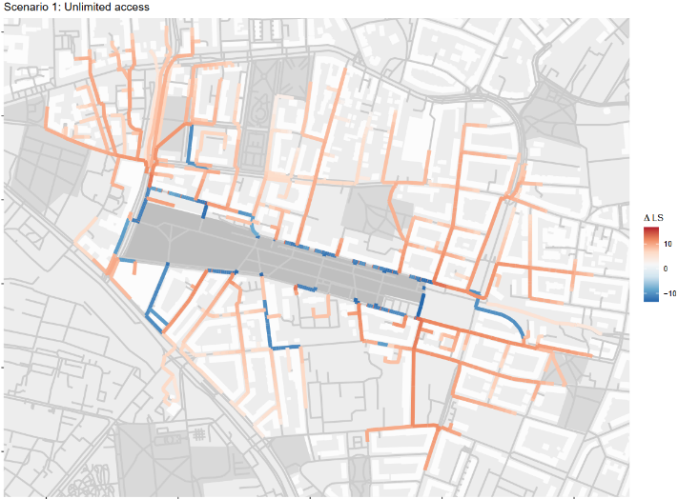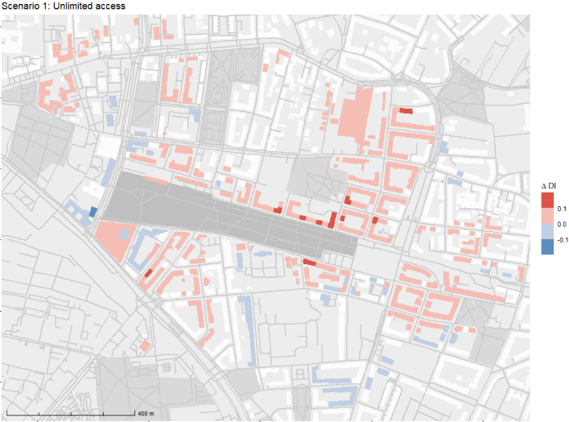

Figure 4 Delta values for local significance (left) and detour index (right). Streets and buildings that expressed no change are not colored. Increase is mapped in red, decrease in blue. The top two map show the unlimited access scenario.

* + In the first scenario we demonstrated how the LS and DI indicators would change if all barriers obstructing access to the Lene-Voigt-Park (LVP) were to be removed.
  + We did so by assuming a park entry every 5 m on the network surrounding Lene-Voigt-Park.
  + As can be seen in figure x_a, a decrease in LS values occurs on all streets that are adjacent to the LVP.
  + On most of the remaining streets, we observe an increase in LS.
  + Thus, according to our model, removing the barriers along the edges of the LVP would, result in less crowded streets surrounding the park.
  + On the other hand, more people could reach the LVP, increasing the overall amount of people traveling through net network.
  + Figure x_b shows the change of the DI values in the first scenario.
  + Overall, we mostly observe minor changes of DI values (delta-DI < 0.1).
  + We filtered out any delta-DI values that were below 0.05 to place emphasis on the more significant changes.
  + It appears as though the change of DI values is mostly limited to buildings that are either very close to the park or that are now inside the threshold network distance.
  + A few buildings adjacent to the eastern part of the LVP express an increase larger than 10%.
  + A larger area to the northeast and smaller areas to the east and south of the center of the LVP show a minor increase of DI values.
  + These buildings may now be able to take a more efficient trajectory towards the LVP.
  + In the northwest of the map we see a cluster of buildings that seems to have gained access to the LVP via a direct path, which increased their DI values.
  + Contrary, in the southeast there is a couple of buildings that have gained access as well, but on a less direct path.
  + For these buildings the DI values decreases.

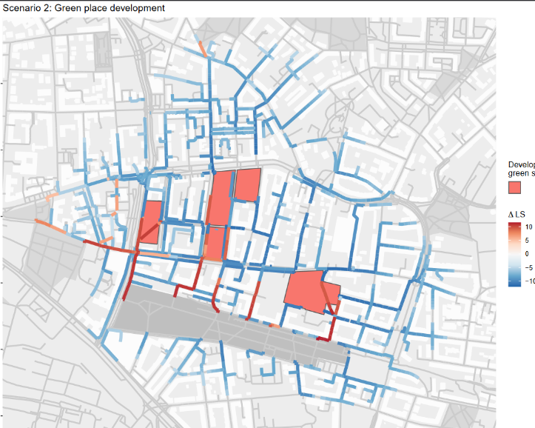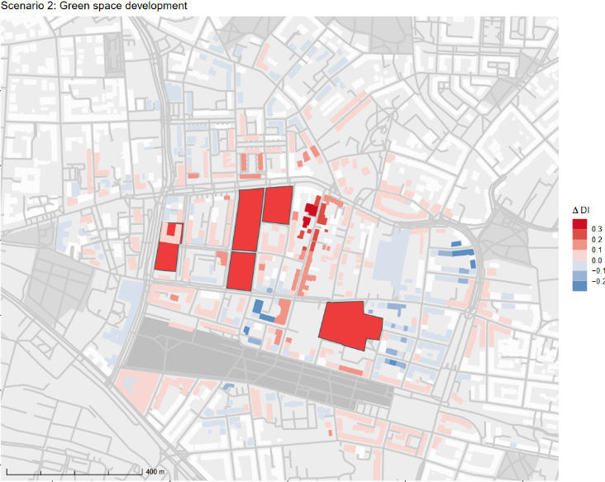

* Scenario 2 – Green space development
  + In the second scenario we intended to see how the indices behave if the green spaces in the city blocks north of the LVP were to be developed into residential areas.
  + To apply these changes, we switched the former park entries into building entries and distributed among them population according to the former park’s size.
  + Figure x-c shows that overall, most of the LS values appear to decrease substantially.
  + Only on the paths connecting the newly built residential areas to the LVP and the former *Johannes-cemetery* in the west can we see a substantial increase of LS values.
  + The reduction of the number of parks in the area seems to have a larger effect on the LS-index than the increase in population.
  + In Figure X-d we see DI values mostly increasing in the area.
  + Especially the buildings along the *Heinrichstraße* that leads from the center of the LVP north experience a substantial DI increase.
  + Some areas in the east and north of the map express a decrease of DI values.
  + South and west of the LVP we observe a mixed picture of minor de- and increases.
  + The five green spaces that we intended to develop are rather small and, thus, hard to reach.
  + Taking them out of the equation seems to leave the surrounding buildings with more efficient trajectories towards the larger parks.
* Scenario 3 – Population increase
  + The third scenario is designed to demonstrate how a population increase would affect the DI and LS indices.
  + In this scenario, we assumed for each residential building a population increase to the 95th percentile of the population per area according to its urban atlas residential class.
  + Since we did not change the locations of any green space or building entries, the DI index did not change, either.
  + 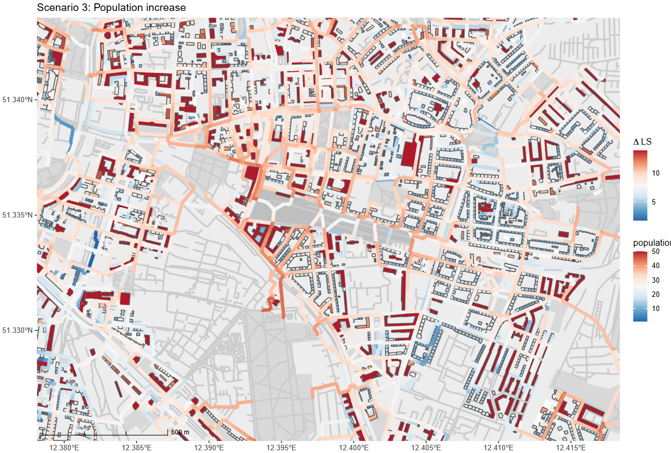As we can see in figure x, the delta-LS is positive in the entire area, so the colors are to be interpreted as in the basic map without changes.
  + In this scenario, we see a similar pattern as in the basic LS map (see figure x).
  + LS tends to grow larger, the closer a street is to one of the large parks.
  + Here, we can observe the highest values between the LVP and the Friedenspark in the south of LVP.
  + The further away a street is from the larger parks, the lower the increase of the LS.
  + Close to LVP the area with the highest values is now in the west, instead of in the east as in the base scenario.
  + If we have a look at the population data that is attached to the residential buildings, we can see that the area in the northwest of the LVP has several buildings with very high population.
  + Most of these buildings can reach the LVP only via the entry point at the northwest, which causes the high LS values in this area.
* Scenario 4 – Ensemble model
  + In the final scenario, we applied all the changes of the previous three scenarios at once.
  + The joint effects of removing barriers, developing the green space in the north and a population increase can be seen in figures x a and b.
  + Figure x a, shows that the change of the LS index is mostly influenced by the population increase and the green space development scenarios.
  + Due to the population increase scenario, we see a general increase of LS, except for those streets that experience a decrease of LS due to the removed green spaces.
  + Similar to the population increase scenario, we see a large area with high LS increase in the northwest of the LVP.
  + In this scenario we can simultaneously observe the effects of the population increase and the unlimited access scenarios.
  + The nearest entry point of area with the high population residential buildings in the northwest has been shifted to the northernmost corner of the LVP in contrast to the third scenario.

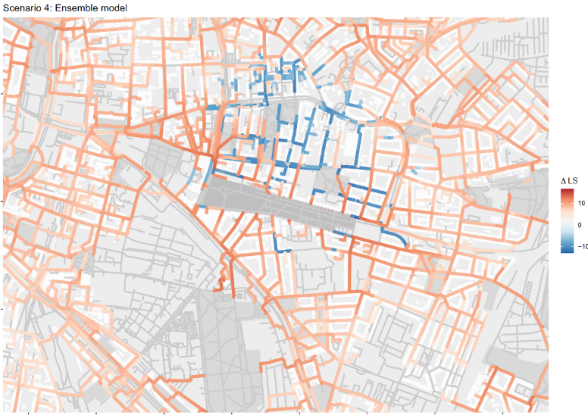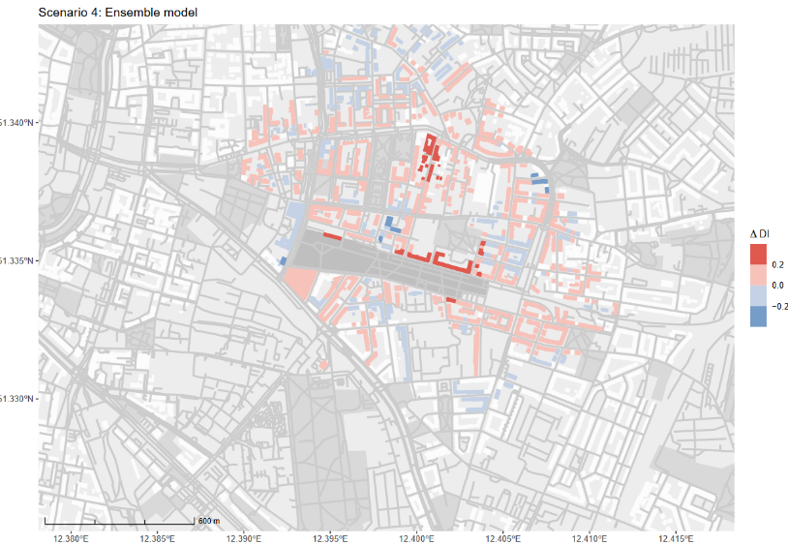

* + As we can observe in figure x b, change of DI is restricted to those buildings that either reached one of the now developed green spaces before or that can reach the LVP through one of the new entry points.
  + In the fourth scenario we can still see an overall increase in DI from removing the small and hard-to-reach green space in the north of the LVP.
  + Also, the mixed effects from removing the entry barriers to the LVP can still be observed in the south or the northwest of the LVP.
* Europe comparison

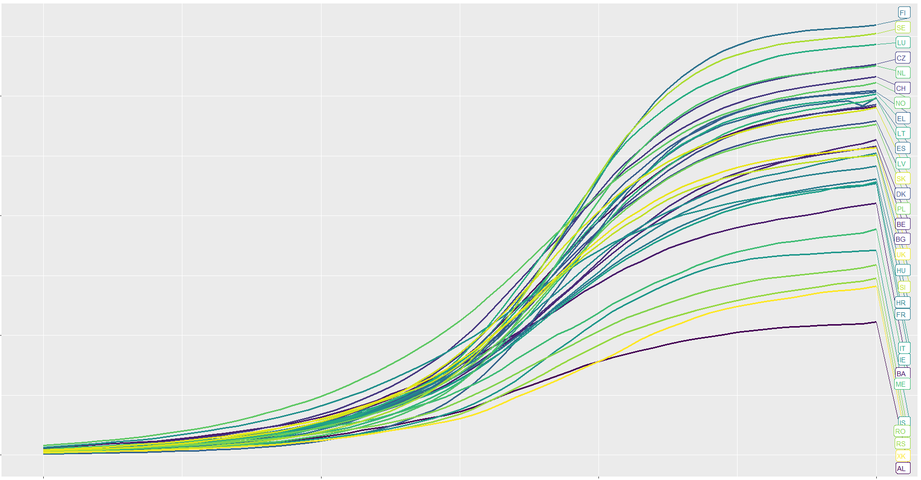

Figure 5 Detour Index (x-axis) and relative cumulative population (y-axis) aggregated by country.

* + Spatial clustering DI
    - As we can see in figur­­­­e 5, the distribution of DI values plotted against population varies strongly across countries.
    - The ending points of the lines show the percentage of people with green space in a network distance of 500 meters.
    - The slopes of the lines show how direct the inhabitants of a country can travel to the green spaces they have access to.
    - While some countries like Finland, Sweden and Luxembourg reach values of

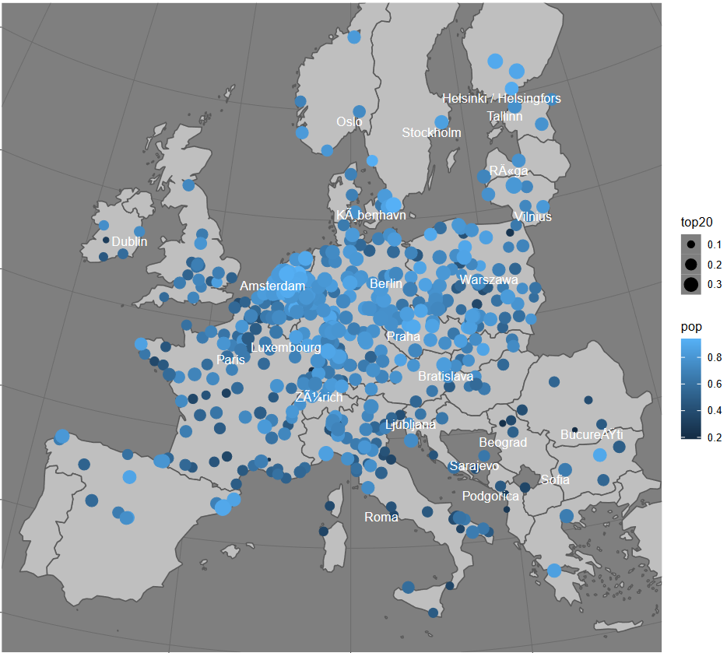

Figure 6 Percent of population with an DI value of > 0.8 (size) and percent of population in 500 meters network distance of green spaces (color)

* + - Explain some countries with high DI / pop and some with low
  + E.g.:
* Results of Objective 1
  + What was feasible? What not? Where? Why?
  + Maps / graphs showing OSM data coverage in different areas
  + How many cities will be “usable”?

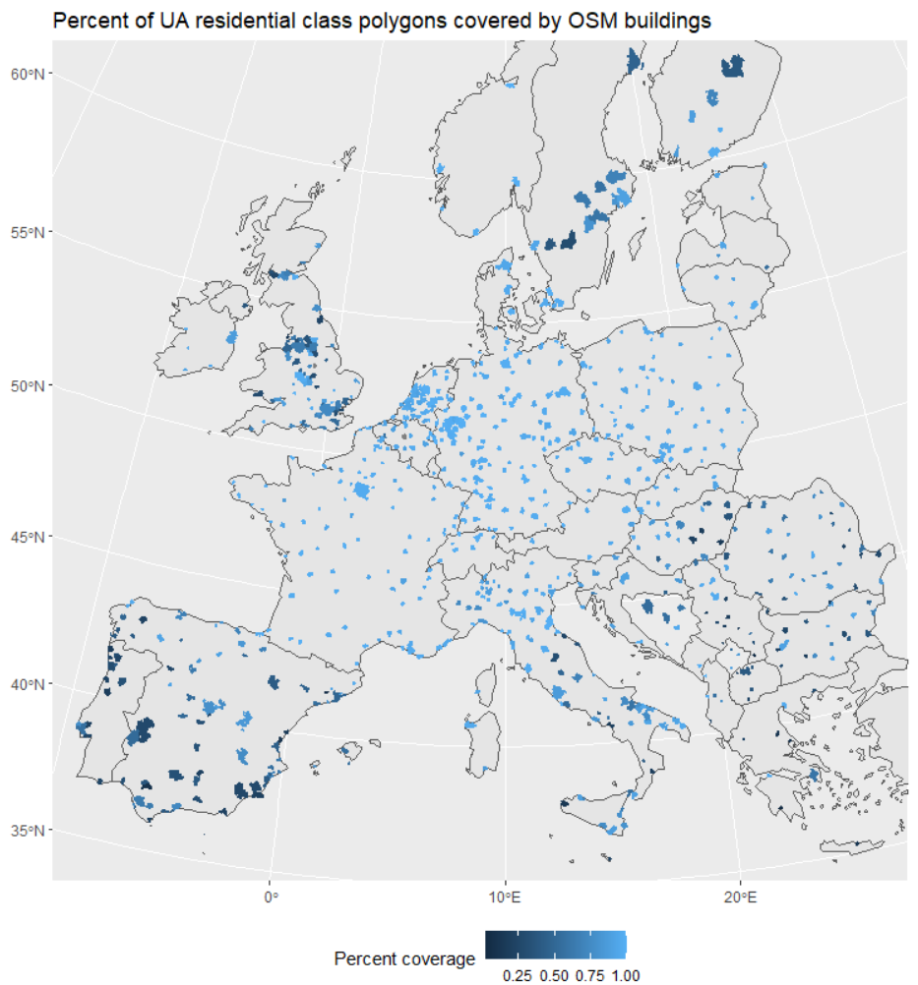

Figure 1: Percentage of urban atlas residential class polygons that contain at least on OpenStreetMap building polygon. Brighter colors represent a higher coverage.